Self-help
Self-responsibility
Equity
Equality
Democracy
Solidarity

Policy/Procedure: Acceptable Use of ICT Policy: Foundation Stage & Key Stage 1 Primary Pupils

First approved by Trust Board: March 2015
Review Frequency: Every Two Years
Date of last review: July 2019
Date of next review: July 2021

Osborne Co-operative Academy Trust
Foundation Stage & Key Stage 1 Primary Pupils

Osborne Co-operative Academy Trust is a multi-academy trust (MAT) incorporated around the principles and values of the international co-operative movement. These are Equality, Equity, Democracy, Self-help, Self-Responsibility and Solidarity, along with the ethical values of openness, honesty, social responsibility and caring for others. These values and principles underpin all our actions.

EYFS/KS1 Pupil Acceptable Use

This is how we stay safe when we use computers:
- I will ask a teacher or suitable adult if I want to use the computers / tablets
- I will only use activities that a teacher or suitable adult has told or allowed me to use
- I will take care of the computer and other equipment
- I will ask for help from a teacher or suitable adult if I am not sure what to do or if I think I have done something wrong
- I will tell a teacher or suitable adult if I see something that upsets me on the screen
- I will only send friendly and polite messages
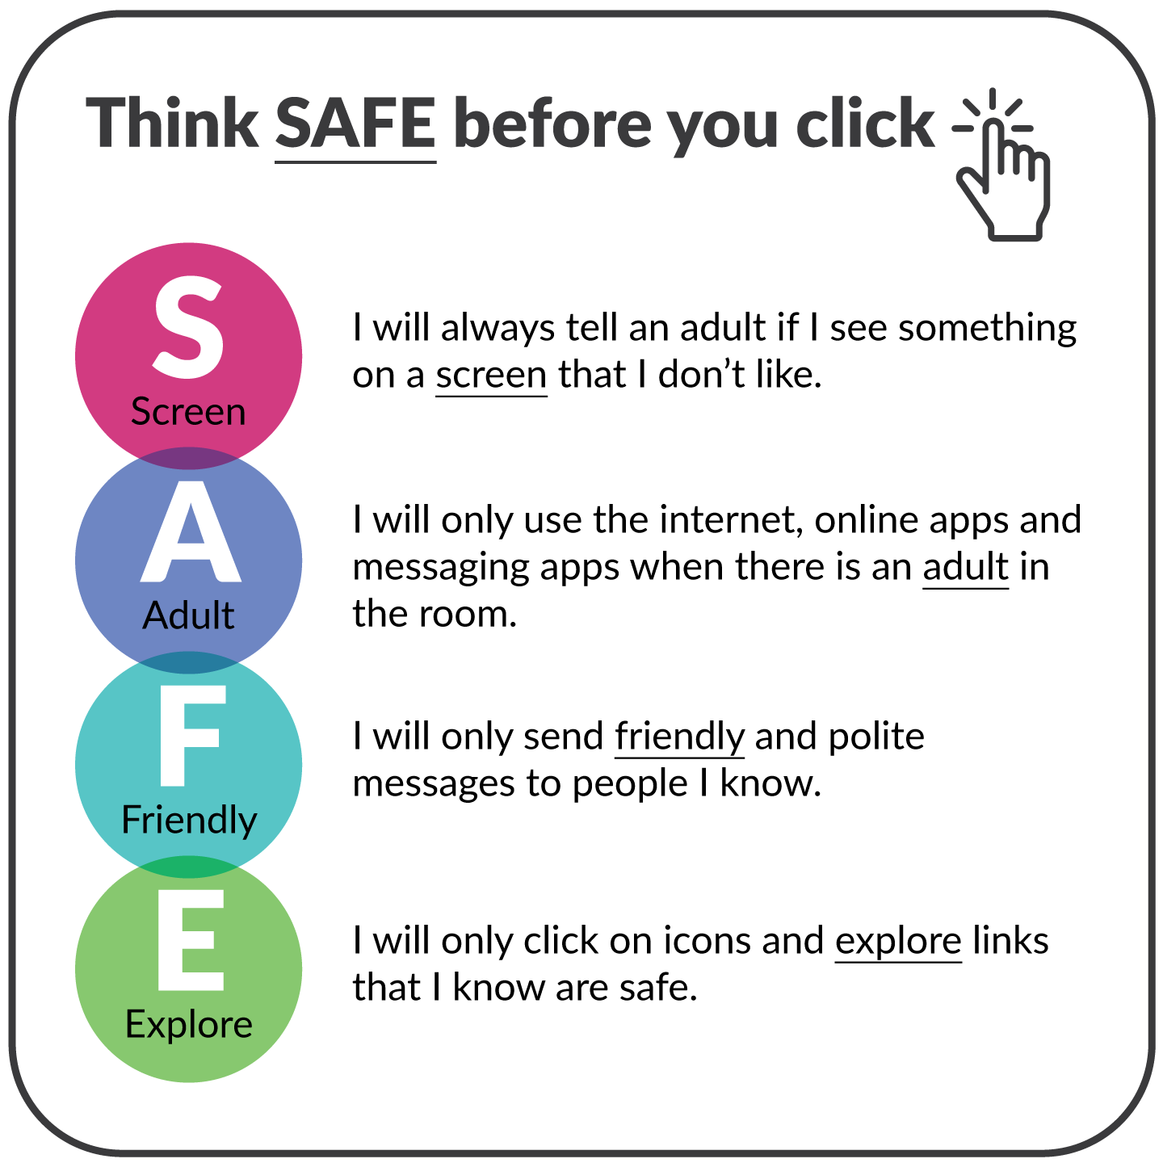
- I know that if I break the rules, I might not be allowed to use a computer / tablet

